Oak Wilt

Oak wilt occurs west of the Susquehanna River in Pennsylvania.

The fungus, Ceratocystis fagacearum, attacks most oaks but especially those in the red oak group (Quercus rubra; northern pin, Q. ellipsoidalis ; shumard, Q. shumardii). American, Chinese, and European chestnuts, tanbark oak, and bush chinquapin are also susceptible. White (Q. alba) and bur oaks (Q. macrocarpa) are less susceptible than red oaks. Susceptible trees die within a few weeks, while those with some resistance may decline slowly for 2 to 3 years or may recover.
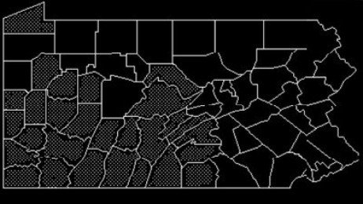

Symptoms
Leaves at the top of the tree turn brown along the tips and margins, wilt, and soon begin to fall while there is still some green color left in them. This progresses down the tree. Twigs and branches die and often have brown streaks in the outer sapwood. When the ends of twigs are cut, the outermost annual ring may be completely brown. A fungal mat develops under the bark and erupts through the bark in the spring.

Spread
- Sap-feeding and bark beetles feed on the fungal mat that erupts through the bark in the spring and pick up sticky spores. They spread the spores as they move short distances to adjacent oaks to feed on fresh, bleeding wounds. A fresh wound is required by the fungus in order to invade. It is thought that beetles are not responsible for spreading the fungus for long distances.
- The fungus remains viable under firmly attached bark. Transport of infected logs is one way the fungus can be moved long distances.
- The most important means of spread in a local area is through roots naturally grafted to the infected tree.
Management: First, obtain a positive diagnosis that oak wilt is the cause of the wilting and defoliation.
Break root grafts to nearby oaks before removing an infected tree. This can be done by trenching or fumigating midway between oaks that are within 50 feet of the infected oak, to a depth of 3 feet. Fumigation is best done when the soil temperature is at least 50°F.
After root grafts are disrupted, remove infected trees. Bury, burn, or debark the logs and stump. Do not stack or transport any wood from the tree if it has bark firmly attached because insects in it may leave and carry the fungus to other oaks.
Do not prune oaks in the late spring or summer because this creates fresh wounds that are attractive to insects that may be carrying the fungus. Prune only during November through mid-April.
The disease in trees with less than 30% of the crown affected can be put into temporary remission by injecting a fungicide. The fungicide does not kill the fungus that is already in the tree's roots. Therefore, root grafts between this tree and neighboring oaks must be disrupted even if the tree is injected with fungicide. It is reported that oaks in high risk areas, but that are not yet infected, can be protected by injecting a fungicide once every 2 years.
Prepared by Gary W. Moorman, Professor of Plant Pathology
For more information, please go to the Penn State Extension Website at https://extension.psu.edu/
The Borough of Fox Chapel cannot recommend any landscaper, arborist, or tree removal company to residents.

